3GPP TSG RAN WG1 #125 R1-2604581
Dalian, China, May. 18th ~ 22nd, 2026

Agenda Item: 10.8.2
Source: T-Mobile USA, Deutsche Telekom
Title: Discussion on 6G sensing overhead and integration with communication
Document for: Discussion/Decision

Introduction

A revised SID on Study on 6G Radio was agreed at RAN#110 [1], which is inclusive of the following objectives related to sensing/ISAC (Integrated Sensing and Communications):
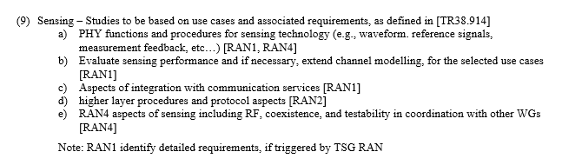
Integrated Sensing and Communication (ISAC) facilitates new 6G applications and services that require sensing capabilities and many potential use cases have been studied in SA in TR 22.870 [2]. The service includes offering wide area multi-dimensional sensing that provides spatial information about unconnected objects as well as connected devices and their movements and surroundings. Normative service requirements for ISAC have been specified in TS 22.137 [3]. Furthermore, RAN1 has made some initial studies in NR as part of Rel-20 [4], which could possibly be leveraged as a starting point for 6G requirements, evaluations, measurements, and channel modelling that are captured in draft TR 38.765 [5] with initial focus on UAV detection using gNB-based monostatic sensing and reuse of NR waveforms.

From a mobile network operator (MNO) perspective, ISAC in 6G should evolve from a technology feasible feature into a deployable, scalable, and monetizable network capability, tightly integrated with communications infrastructure and services.

In particular, the following principles for ISAC in 6G should be targeted as part of this study:
- Reuse of communications signals, existing spectrum, and network assets
- New revenue-generating services (e.g., sensing for diverse device types such as handheld, CPE and IoT, smart city, enterprise)
- Minimal impact to communication performance and resources
Based on the progress at RAN1#124-bis, specific to aspects of integration with communication, the following was agreed [8]:
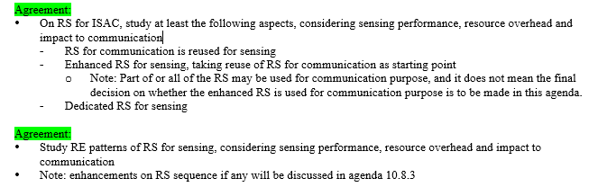
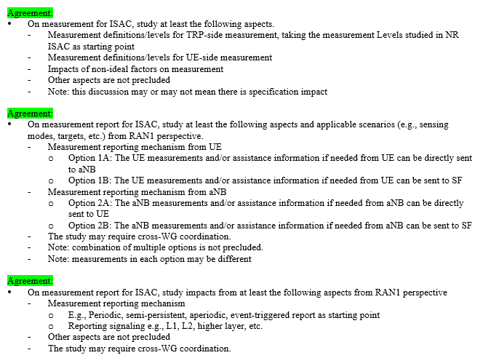

This contribution investigates some of these issues and topics for ISAC aspects of integration with communication, focusing on the overhead aspects for the study phase.

Resource overhead for Sensing

Sensing Reference Signals

Sensing performance and KPIs should not be the only criteria investigated for ISAC evaluations in the study phase for Rel-20. Complexity and sensing resource requirements/overhead are also a key aspect for ISAC evaluations. From an MNO perspective, the starting point should be to maximize reuse of existing communication RS and avoid introducing new RS unless there is clear, quantified benefit. This minimizes specification complexity, UE/network impacts, and resource overhead. As discussed in RAN1#124-bis, there were three options outlined for sensing RS:
- RS for communication is reused for sensing
- Enhanced RS for sensing, taking reuse of RS for communication as starting point
Note: Part of or all of the RS may be used for communication purpose.
- Dedicated RS for sensing

Evaluations of sensing performance using reused RS should be the starting point, and new or enhanced RS shall only be considered if reuse is shown to be insufficient. Reuse of existing RS minimizes specification workload/complexity, reduces implementation complexity, minimizes impact to legacy communication procedures, and does not add additional resource overhead.

Candidate RS for reuse may include, for example, CSI-RS for “downlink-based” (TRP-based) sensing, and SRS for “uplink-based” (UE-based) sensing.

Proposal 1: RAN1 prioritizes reuse of communication reference signals (RS) as the baseline for 6G sensing, and evaluates sensing performance achievable, including identification of any performance gaps relative to sensing KPIs.

RE patterns for sensing performance

From an MNO perspective, the study of RE pattern design for RS used in sensing should focus on evaluating how different RE allocations impact the trade-offs between sensing performance, resource overhead, and communication performance. In particular, RAN1 should evaluate variations in RS density (e.g., sparse vs. dense patterns), distribution (e.g., contiguous vs. distributed in time/frequency), and spatial characteristics (e.g., antenna/beam domain allocation), and their effect on sensing KPIs such as accuracy, resolution, detection reliability, and latency. These evaluations should be conducted using reused communication RS (e.g., CSI-RS, SRS) as the baseline, with any enhancements assessed incrementally. A key aspect is to determine whether improvements in sensing performance from modified RE patterns are significant enough to justify the associated increase in resource usage or constraints on communication scheduling.

In addition, RAN1 should consider the impact of RE pattern design on communication performance, including potential interference, reduced data-carrying resources, and increased scheduling complexity. It is important that RE patterns remain configurable and adaptable to different deployment scenarios (e.g., dense urban, high mobility). From an operator standpoint, it is important to leverage RS resources that can be jointly utilized for both communication and sensing, thereby minimizing overhead. Overall, the evaluation should aim to identify RE pattern configurations that provide a balanced and scalable solution, delivering meaningful sensing gains without compromising the primary communication function of the network.

Proposal 2: RAN1 considers studying different resource element (RE) patterns for RS including, sparse vs dense RS patterns, distributed vs clustered RE allocation, time/frequency/space multiplexing, flexible/adaptable configurations. Other RE pattern aspects are not precluded.

Sensing resource overhead and classifications

For all 3 options for sensing reference signals (i.e., reused communications RS, enhanced communications RS for sensing or dedicated RS for sensing), clear resource overhead definitions and overhead calculations/ratios must be defined for evaluations.

Looking back on the NR ISAC agreements in TR 38.765, RAN1 has defined three types of resources and associated sensing overhead calculations, and these classifications should be applicable for 6G ISAC. To define the sensing resource ratio used in the evaluation of NR ISAC, the following resources are defined in the draft TR 38.765 [4]:

• Type 1: resources that are used for sensing signal transmission
• Type 2: part of Type 1 resources that are used for communication purposes
- Note: it is possible the resource type 2 doesn’t exist
• Type 3: resources that are not used for sensing signal transmission, and cannot be used for communication purposes due to sensing operation

However, for the NR ISAC evaluations it not completely clear what are the design targets and a clear definition of overhead is still not fully defined.
On the latter point for T/F RE mapping of sensing RS, it is unclear if Type 1 resources are, e.g., calculated for resources that are exclusively used for sensing purposes only. For example, it’s ambiguous what resources that might be, e.g., used for both sensing and communications, and what we really need to understand is what resources are only unavailable for communication purposes that are used in sensing ratio calculations. It would be best to get a common clear understanding of resources required for sensing signal transmission and an accurate account for how much resources are exclusively utilized for sensing purposes to meet the minimum performance metrics. It is proposed that RAN1 clarifies this calculation and dependent upon the sensing solution, one or more of the resource types may not exist.
Observation 1: Resource types used for defining sensing resource ratios per the draft TR 38.765 are ambiguous with respect to what are considered resources for sensing (signal transmission & operation) versus communication purposes. A clear definition of overhead and design targets for, e.g., calculated for resources that are exclusively used for sensing purposes, distinguished from the resources that can also be used for communication purposes, would be beneficial for a common understanding for 6G evaluations.

Proposal 3: RAN1 considers the following for resource types (similar to the baseline TR 38.765) when considering sensing overhead and design targets:
• Type 1: resources that are used exclusively for sensing signal transmission
• Type 2: resources that are used for both communication purposes and sensing purposes.
• Type 3: resources that are not used for sensing signal transmission, and cannot be used for communication purposes due to sensing operation(s)
- Note: it is possible that one or more resource types doesn’t exist depending on the sensing configuration.

Another aspect in RAN1 ISAC evaluations are the design targets and sensing overhead targets, an essential aspect from the mobile network operator perspective. Two options for the sensing resource ratio are described in the draft TR: Option 1: (Type_1 + Type_3) resources over all radio DL and UL resources and option 2: (Type_1 - Type_2 + Type_3) resources over all radio DL and UL resources. Currently, there is no guidance on any sensing ratio/overhead targets, which should be further studied. Also, depending on the sensing procedures, sensing resources may also be muted (for hearability) and unable to be used for communication purposes, and reflected in the “resource types”.

In early RAN1 discussions and moderator summaries, a suggested a value of up to 10% for sensing overhead has been proposed for NR. From the MNO perspective, that value could be significantly higher than an acceptable sensing ratio overhead value or this could be much lower depending on various factors while meeting KPI targets. Various factors could be considered for adjusting sensing resources, e.g., network load and priority, sensing target types, similar to TS 22.137 ISAC requirements, suggesting dynamic sensing resource allocation:

“Subject to regulation and operator policy, the 5G network shall be able to activate, configure, and deactivate 5G wireless sensing based on parameters such as location and network conditions (e.g., network load).”

“Subject to regulation and operator’s policy, 5G network shall provide prioritization among 5G wireless sensing services as well as prioritizing between communication and sensing services.”

Without a specific target sensing resource ratio value, RAN1 design objectives should include evaluation of required sensing resources that are exclusively used for sensing purposes (i.e., not available for communication purposes, including muted resources) while meeting one or more sensing service category target KPIs/metrics accounting for various dynamic factors, such as network load, target types, clutter, and priority, etc. for sensing versus communications resources. In some cases, alternative non-3GPP sensing could be used. This could be done dynamically based on thesevarious factors.

Proposal 4: RAN1 discuss and consider adding design targets as part of the 6G evaluations for sensing, including overhead for resources that are exclusively used for sensing purposes (i.e., unable to be used for communication purposes, including muted resources) while meeting minimum performance requirements for one or more sensing service category target KPIs/metrics, accounting for dynamic factors, e.g., network load and priority.

Conclusions
In this contribution, we presented our observations and proposals for sensing aspects of integration with communication, focusing on the resource overhead for the study phase in Rel-20. Herein, we make the following proposals:

Proposal 1: RAN1 prioritizes reuse of communication reference signals (RS) as the baseline for 6G sensing, and evaluates sensing performance achievable, including identification of performance gaps relative to sensing requirements.

Proposal 2: RAN1 considers studying different resource element (RE) patterns for RS including, such as sparse vs dense RS patterns, distributed vs clustered RE allocation, time/frequency/space multiplexing, flexible/adaptable configurations. Other RE patterns are not precluded.

Proposal 3: RAN1 considers the following for resource types (similar to the baseline TR 38.765) when considering sensing overhead and design targets:
• Type 1: resources that are used exclusively for sensing signal transmission
• Type 2: resources that are used for both communication purposes and sensing purposes.
• Type 3: resources that are not used for sensing signal transmission, and cannot be used for communication purposes due to sensing operation(s)
- Note: it is possible that one or more resource types doesn’t exist depending on the sensing configuration.

Proposal 4: RAN1 discuss and consider adding design targets as part of the 6G evaluations for sensing, including overhead for resources that are exclusively used for sensing purposes (i.e., unable to be used for communication purposes, including muted resources) while meeting minimum performance requirements for one or more sensing service category target KPIs/metrics, accounting for dynamic factors, e.g., network load and priority.

Reference
[1] 3GPP RP-253876 Revised SID: Study on 6G Radio, Rel-20
[2] 3GPP TR 22.870 Study on 6G Use Cases and Service Requirements; Stage 1 (Release 20)
[3] 3GPP TS 22.137 Service Requirements for Integrated Sensing and Communication, Stage 1, Rel. 19.
[4] 3GPP RP-253246 Study on Integrated Sensing And Communication (ISAC) for NR (Release 20)
[5] 3GPP TR 38.765 Study on Integrated Sensing And Communication (ISAC) for NR (Release 20)
[6] 3GPP TR 38.901 Study on channel model for frequencies from 0.5 to 100 GHz (Release 19)
[7] 3GPP TR 38.914 Study on 6G Scenarios and Requirements;(Release 20), v0.4.0.
[8] R1-2603284 Session Notes of AI 10.8(ISAC), Ad-Hoc Chair (NTT DOCOMO, INC.)

